Analog Circuit and signals
Laboratory
Linear Integrated Circuits Lab
(22ECP210, B Tech III Semester)

Lab Project


Department of Electronics and Communication Engineering Malaviya National Institute of Technology Jaipur
Jaipur-India, 302017

Project Performed By :

AAKASH KUMAR( 2024UEC1706 )
KUSHAL GARG ( 2024UEC1635 )
VIRENDER MEENA ( 2024UEC1711)
RAHUL LAMBA ( 2024UEC1704 )
PRIYANSHU MEEL ( 2024UEC1714 )

Under Guidance Of :

Dr. Ritu Sharma
Sonu Jain

POLICE-STYLE LED FLASHER
1. INTRODUCTION
- This project is a police-style LED flasher built using the popular 555 Timer IC.
- The circuit uses two 555 timers (IC 555-2) arranged in simple astable mode to generate blinking signals.
- It operates from a 9V battery, making it suitable for:
  - Model vehicles
  - Emergency display units
  - Electronics hobby demonstrations
- The flashing pattern is created by alternating a Red LED and a Blue LED, commonly used in police lights.
- The design focuses on:
  - Minimal components
  - Stable flashing
  - Simple timing control using RC networks.

2. COMPONENTS USED & THEIR FUNCTION
A. 555 TIMER IC (2 Pieces)
- Works as an astable multivibrator to generate oscillating square waves.
- First 555 can be used for slow flashing.
- Second 555 (optional) can allow alternating flash patterns.
- Key internal blocks that matter to your project:
  - Comparators → detect capacitor charging and discharging voltages
  - Flip-Flop → stores the ON/OFF state
  - Transistor discharge switch → controls capacitor timing
- Functions related to your circuit:
  - Creates HIGH–LOW transitions automatically
  - Controls LED blink rate
  - Provides enough output current (~200mA max) to drive LEDs directly
B. RESISTORS (47Ω × 2, 1MΩ × 2)
(i)-1MΩ Resistors
- Form the timing resistance in the RC network.
- Control the blinking speed through:
  - Charging time of the capacitor
  - Discharging time through the discharge pin
- High resistance = slower blinking
- Two 1MΩ resistors create the delay equation:
  - T=0.693×(R1+2R2)×CT = 0.693 × (R1 + 2R2) × CT=0.693×(R1+2R2)×C
(ii)-47Ω Resistors
- Used in series with each LED.
- Limit current to prevent LED burnout.
- Without them, LEDs would draw too much current from 12V supply.
C. CAPACITORS (1µF Polarized + 100nF Ceramic)
1µF Electrolytic
- Creates the timing delay that defines flash speed.
- Charges and discharges repeatedly between 1/3 and 2/3 of supply voltage.
- Larger value = slower flash.
100nF Capacitor
- Placed at pin 5 (Control Voltage) of 555.
- Stabilizes internal reference voltage.
- Reduces electrical noise to prevent false triggering.
D. LEDs (Red + Blue)
- Red LED and Blue LED represent police emergency lights.
- Only one LED is ON at a time if alternating mode is used.
- LEDs respond instantly to 555 output level changes.
E. 12V Battery
- Acts as the main power supply.
- Provides stable operation for both timer ICs.
- High enough voltage to drive LEDs brightly with resistors.
F. Buzzer
- The buzzer responds to changing electrical pulses.
- The buzzer tone periodically increases and decreases.
- The buzzer makes tick sound imitates the "woo-woo" pattern of police sirens.
- If LEDs alternate while buzzer frequency shifts, the full emergency effect is achieved.

G. Zero PCB
- Allows permanent soldering of your flashing circuit.
- Provides mechanical stability.
- Ideal for building prototype-level projects.

3.Circuit Connections
A. HOW THE FLASHING HAPPENS
- When output (Pin 3) goes HIGH:
  - Red LED turns ON through its 47Ω resistor.
  - Blue LED remains OFF.
- When output goes LOW:
  - Blue LED turns ON through its 47Ω resistor.
  - Red LED switches OFF.
- Alternating patterns can be achieved by:
  - Two 555 timers controlling opposite LEDs, or
  - A single timer with LED polarity switching.
3. Circuit Connections
Ki CAD model
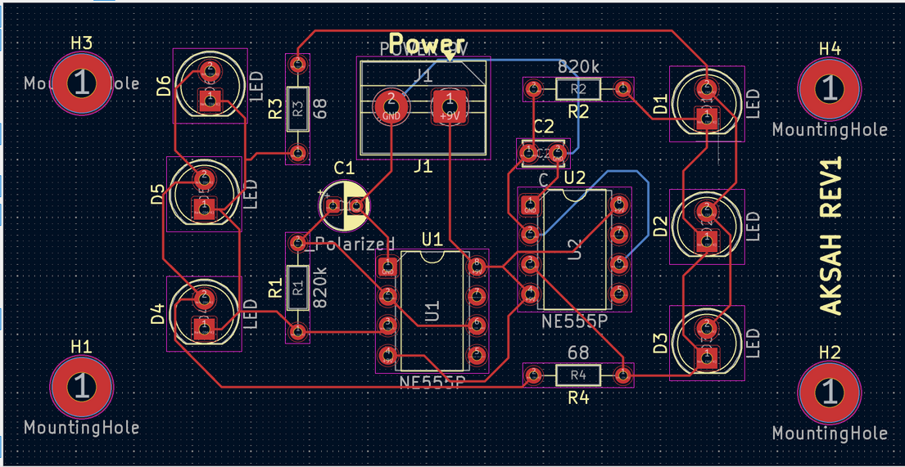

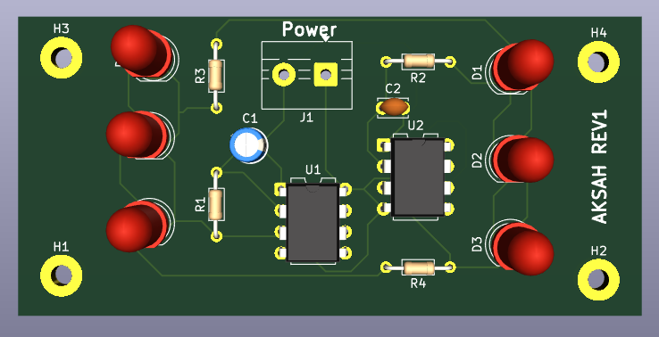

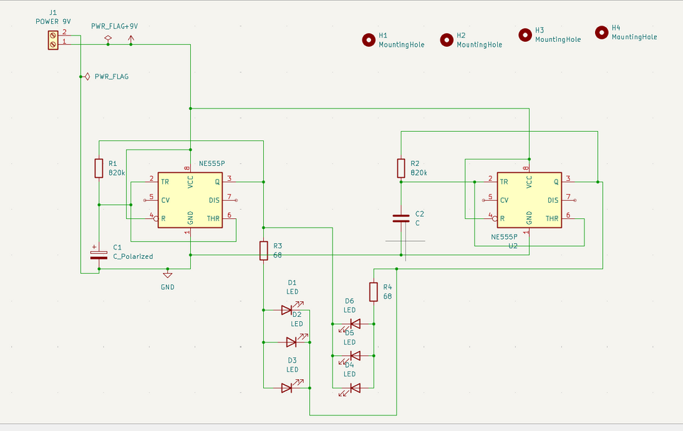
LtSpice model
The output Voltage across PIN 3(1st IC555)
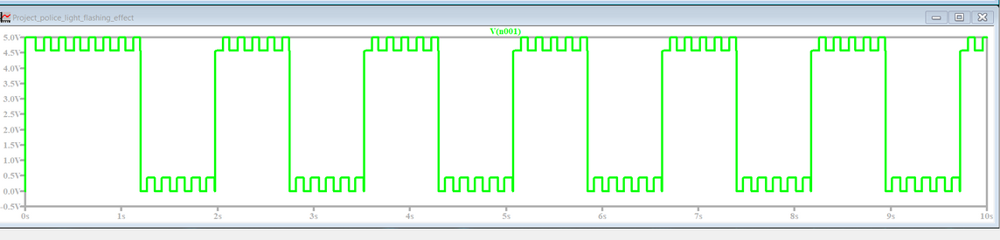
The output Voltage across PIN 3(2nd IC555)
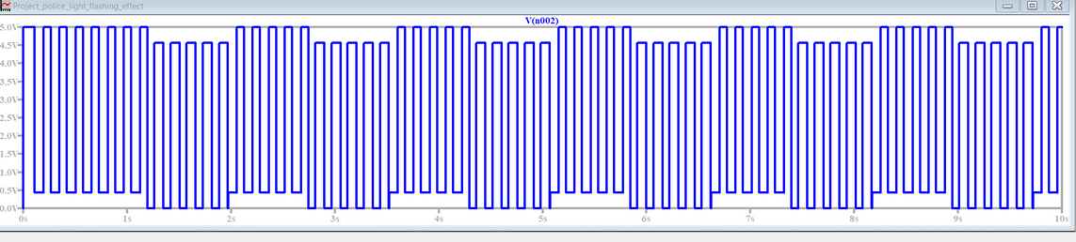

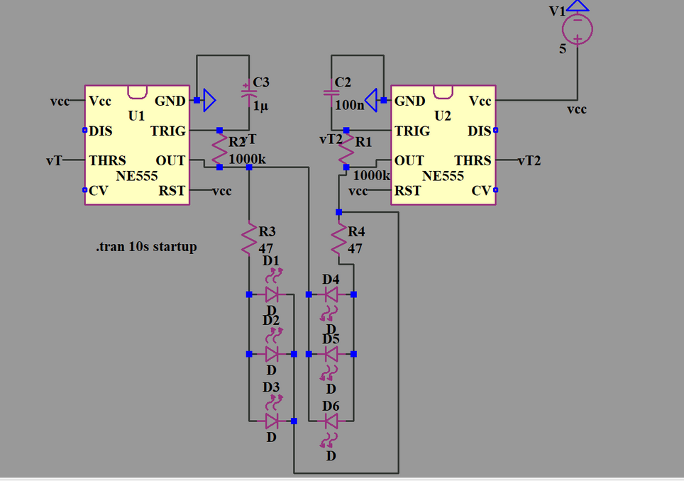

Current across BLUE and RED DIODE
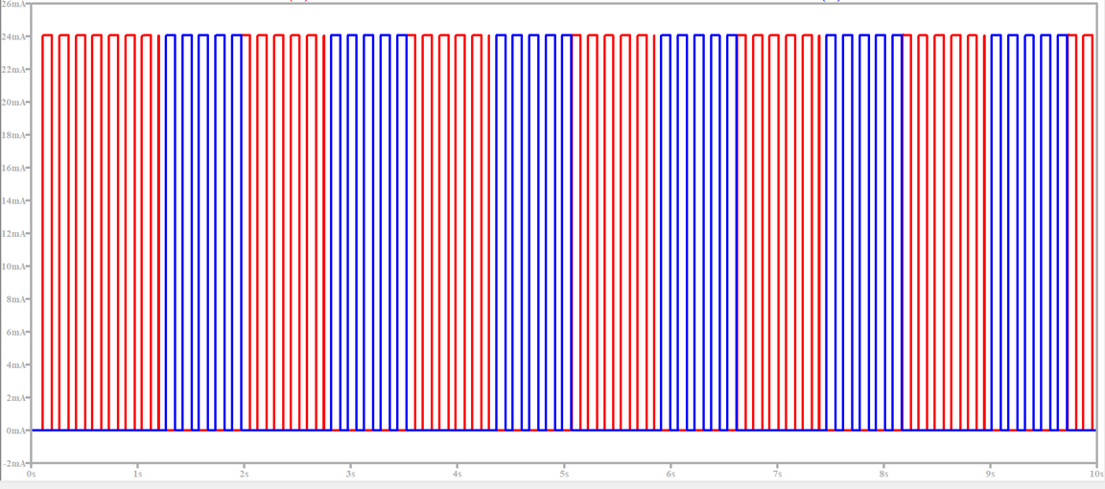
Final Outcome of Project 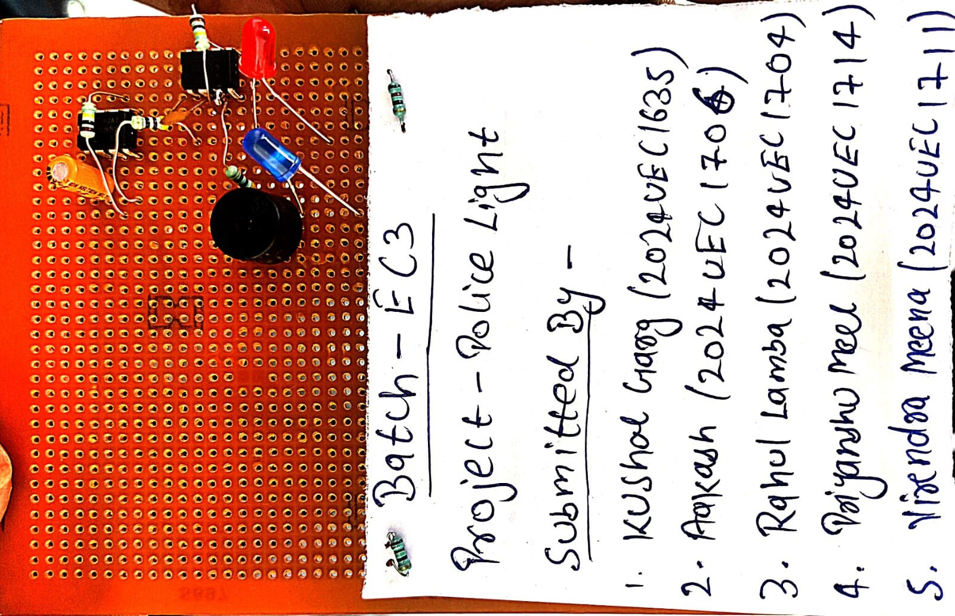

Link for video simulation of our project:-
https://drive.google.com/file/d/1XDolC1LVi5qn3UvnaUAPBcKN104kLhch/view?usp=drive_link

Time Calculation
- The 555 timer is used in astable mode, meaning it produces continuous ON–OFF pulses.
- The blinking speed (flash rate) depends on the resistor–capacitor (RC) network.
⏱ Timing Formula for 555 Astable Mode
First 555IC
- ONE timing resistor (1ΜΩ)
- ONE timing capacitor (1µF)
- A diode around the capacitor making charge/discharge symmetrical
- The ON and OFF times use the same formula:
T=0.693 ×R×C
So:
Charging time (output HIGH):
- THIGH = 0.693 × 1ΜΩ × 1μF THIGH = 0.693 seconds
Discharging time (output LOW):
Same resistor, same capacitor.
- TLOW = 0.693 × 1ΜΩ × 1μF
- TLOW = 0.693 seconds
3. TOTAL Flash Period
TTOTAL THIGH + TLOW T=0.693+0.6931.386 seconds
Full flash cycle ≈ 1.4 seconds
About 0.7 seconds ON and 0.7 seconds OFF
Second 555IC
Full flash cycle ≈ 1.4 seconds/10=0.14s

Working Principle
1. Charging Phase (Output HIGH)
- The 1µF capacitor charges through R1 and 0.1µF capacitor charges through R3 .
- While it charges from 1/3 Vcc → 2/3 Vcc, the 555 output (Pin 3) stays HIGH.
- This turns Red LED ON (Blue OFF).
2. Threshold Point Reached
- When capacitor voltage hits 2/3 of 12V,
→ Upper comparator triggers
→ Flip-flop resets
→ Output goes LOW
→ Discharge transistor activates
3. Discharging Phase (Output LOW)
- The capacitor discharges only through R2 .
- During discharge from 2/3 Vcc → 1/3 Vcc,
→ Output stays LOW
→ Blue LED turns ON (Red OFF).
4. Trigger Point Reached
- When voltage reaches 1/3 Vcc,
→ Lower comparator triggers
→ Flip-flop sets
→ Output returns HIGH
The cycle repeats endlessly.

What We Learned From This Project
1. Understanding of Electronic Components
- Learned how the 555 Timer IC operates in astable mode.
- Understood the role of:
  - 1MΩ timing resistors
  - 47Ω LED resistors
  - 1µF timing capacitor
  - 100nF decoupling capacitor
- Understood how LEDs behave with different duty cycles and currents.
- Learned how a buzzer converts electrical pulses into sound.
2. KiCad PCB Design Knowledge
- Learned how to create a schematic in KiCad:
  - Placing symbols
  - Wiring connections
  - Annotating components
- Understood how to design a custom PCB layout:
  - Footprint selection
  - Track routing
  - Ground planes
  - Via usage
- Gained experience exporting Gerber files for manufacturing.
- Practiced labeling components clearly for assembly.

3. LTSpice Simulation Skills
- Simulated the police flasher circuit in LTSpice:
  - Used 555 model
  - Assigned correct resistor and capacitor values
  - Ran transient analysis (.tran) to observe timing waveform
- Verified:
  - LED switching intervals (~0.7s ON/OFF)
  - Output square wave
  - Capacitor charge/discharge curves
- Learned how simulation helps:
  - Predict real behavior
  - Reduce trial-and-error
  - Confirm correctness before soldering
4. Real-Time Testing and Troubleshooting
- Performed real-world testing using a 12V battery.
- Observed:
  - Blinking LEDs
  - Frequency accuracy
  - Buzzer tone response
- Developed troubleshooting skills:
  - Checking short circuits
  - Testing continuity
  - Fixing reversed-polarity components
  - Replacing faulty LEDs or resistors
- Understood how theoretical designs behave in real hardware.

5. Hands-on Experience
- Soldering, breadboard testing, LTSpice simulation
- Reading pin diagrams and datasheets
- Building functional prototypes

Conclusion
Built a fully functional Police Light + Siren Unit.
Combined visual signaling (LED flashes) with audio signaling (buzzer).
Successfully implemented:
- Design → Simulation → PCB → Soldering → Testing → Final working model
Gained both theoretical knowledge and hands-on engineering experience.

